**SQL Queries**

## **1. Create Table Name : Student and Exam**

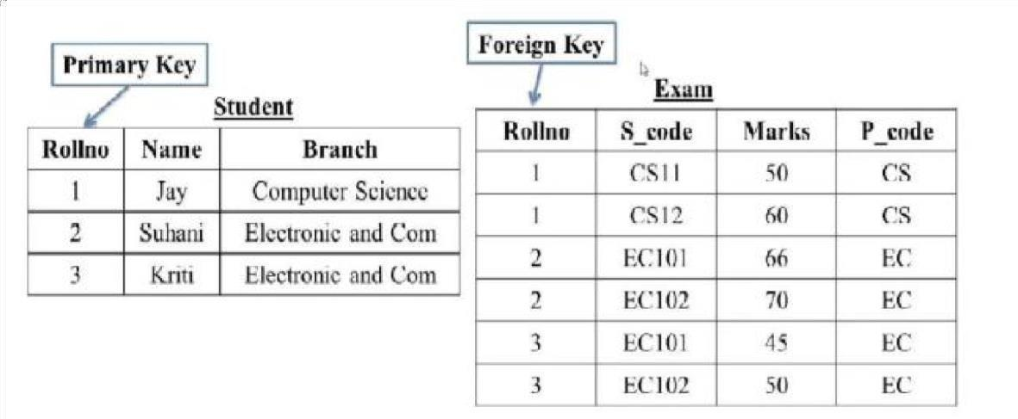

|  |
| --- |
|  |

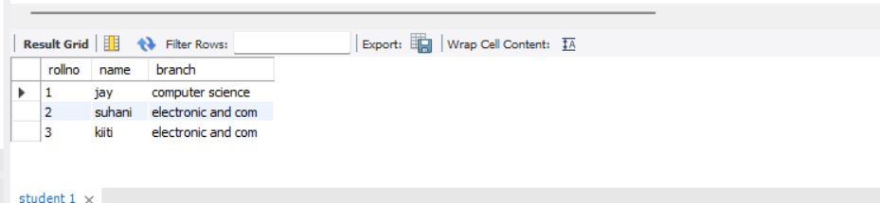

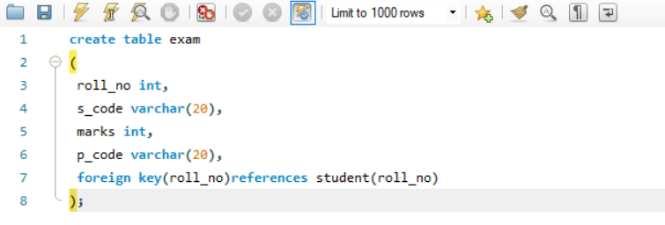

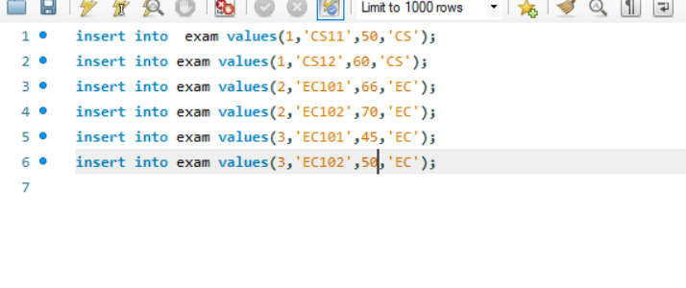

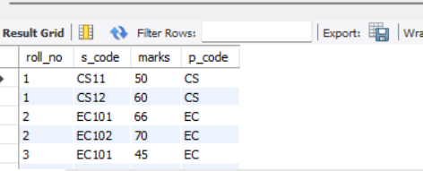

## **2. Create table given below: Employee and IncentiveTable**

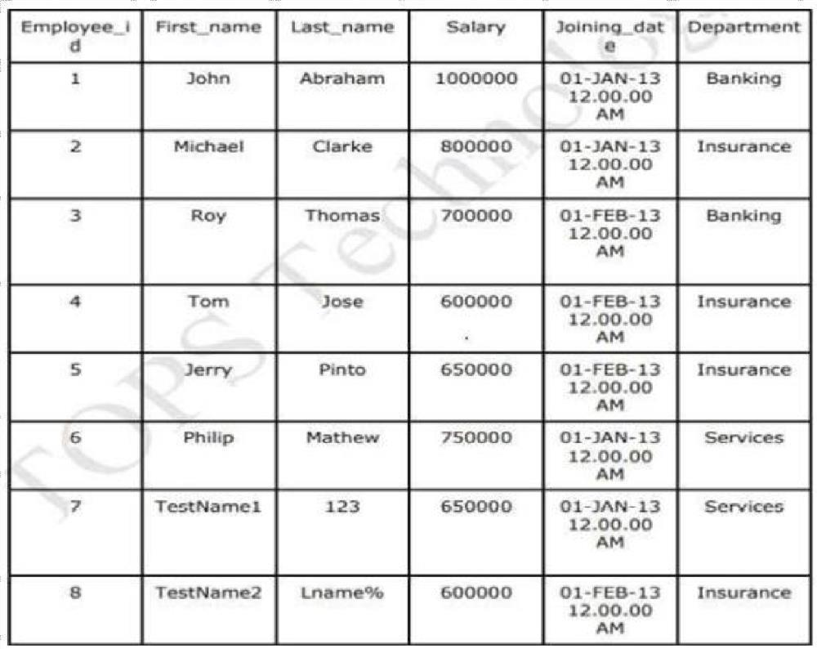

Name: Employee

Table Name: Incentive

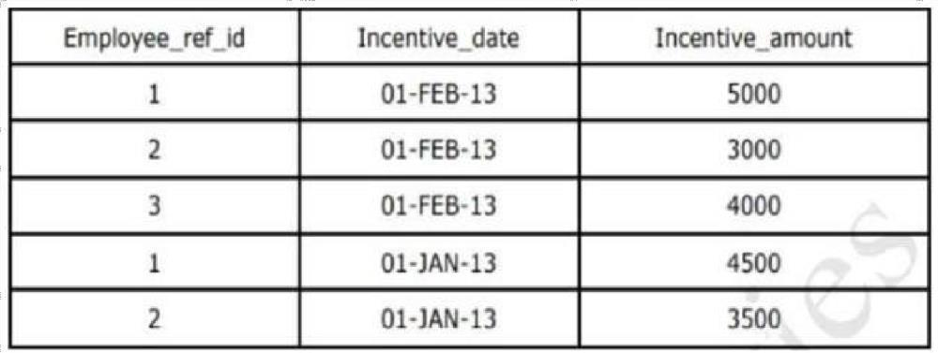

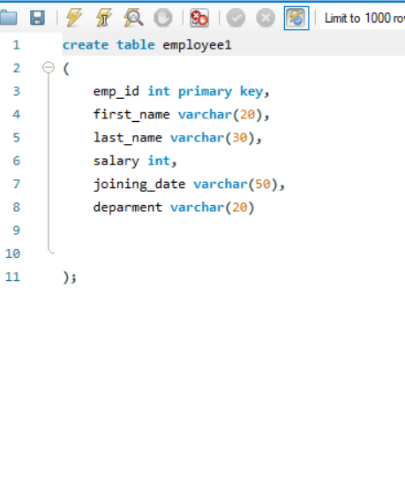

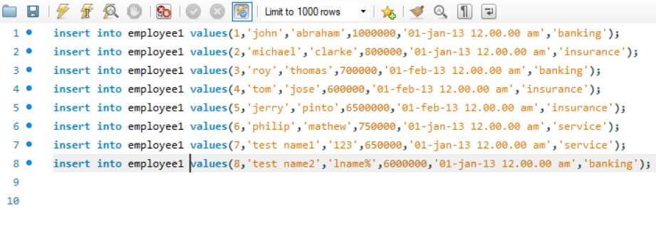

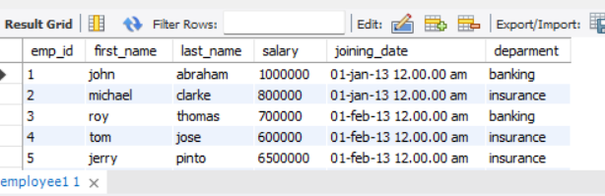

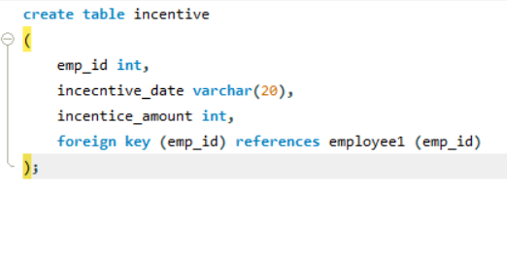

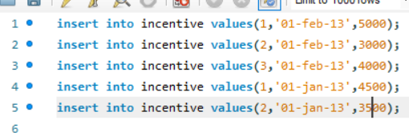

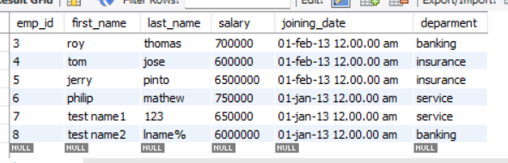

1. **Get First_Name from employee table using Tom name “Employee Name”.**

|  |
| --- |
| [SELECT](http://localhost/phpmyadmin/url.php?url=https://dev.mysql.com/doc/refman/8.0/en/select.html) First_Name from employee where first_name='Tom'; |

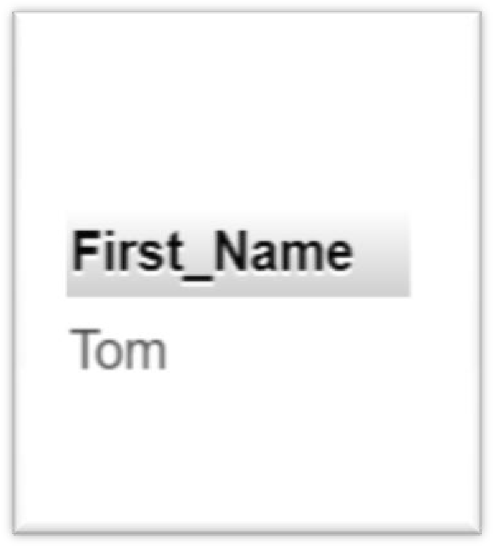

**4 get FIRST_NAME, Joining Date, and Salary from employee table.**

SELECT first_name,Joining_date,salary from employee;

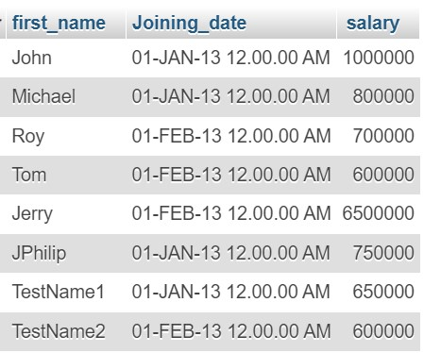

**5 Get all employee details from the employee table order by First_Name Ascending and Salary descending?**

**🡪**select * from `employee` order by first_name,salary DESC ;

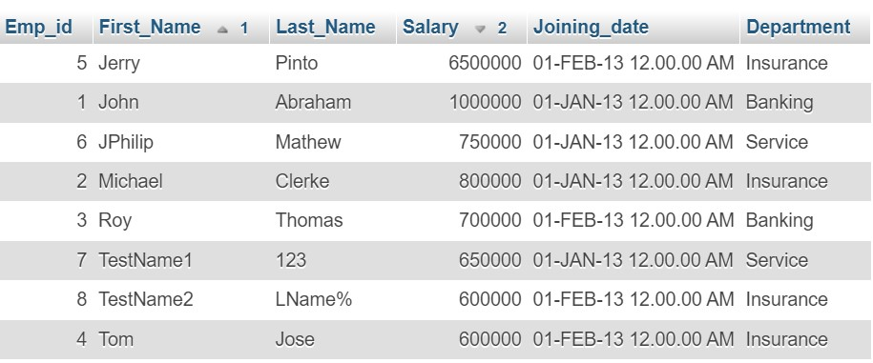

**6 Get employee details from employee table whose first name contains ‘J’.**



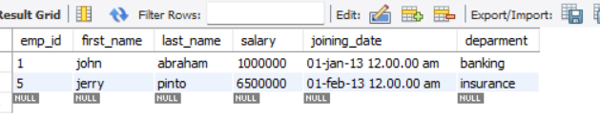

**7 Get department wise maximum salary from employee table order by salary ascending**?



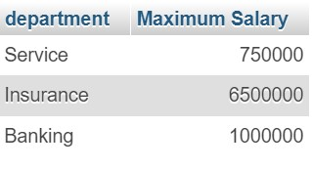

**9 Select first_name, incentive amount from employee and incentives table forthose employees who have incentives and incentive amount greater than 3000**



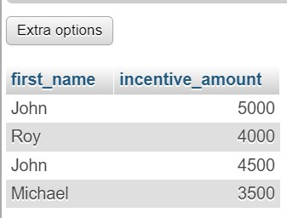

**10 Create After Insert trigger on Employee table which insert records in viewtable**



